**Protocol Layering:**

In case of simple communication, there can be only one simple protocol. However, in case of complex communication, we need a protocol at each layer. This concept is called protocol layering.

**Example of Simple Communication:**

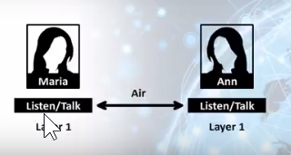

Suppose there are two friends Maria and Ann which are talking to each other. Protocol or rule for their communication can that both friends should communicate with each other in same language or the languages which both friends can understand.

**Example of Complex Communication:**

In complex communication systems we can implement protocol in one simple layer but because of complexities of communication process it is more efficient to implement protocol in multiple layers.

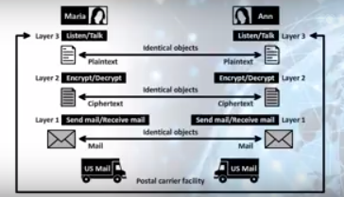

Suppose two friends are living in different cities and they have decided to communicate through postal mail. And they have also decided that their communication should be encrypted so that no other person can read their communication.

In this case we can implement following protocol layers.

On sender side Layer 3 will receive text from sender and write it on paper. Then Layer 2 will plain text into encrypted text or ciphertext. Layer3 will put encrypted letter in envelop and send through postal mail service.

On received side, Layer 1 will receive envelope from postal mail service and will send to Layer 2 for decryption. Layer2 will decrypt ciphertext and convert it to plain text. Then layer1 will show plain text to reader.

**Protocol Layering Advantages:**

1. Modularity
2. Separation of Service and Implementation
3. Reduced complexity and cost

**Protocol Layering Principles**

There are two principles on protocol layering:

1. In Bidirectional communication, each layer performs two opposite tasks in each direction for example if one layer is able to encrypt the message then it should also be able to decrypt the encrypted message.
2. Two objects under each layer at both sites should be identical.

**Transmission Control Protocol / Internet Protocol Suite**

TCP / IP Protocol Suite is the set of protocols in a layered architecture that governs today’s internet. TCP / IP Protocol Suite is composed of multiple layers. Each layer performs a specific function. Each layer works in hierarchical manner which means that each upper layers users the services of its lower layers.